Soulslike game UI Design

Table of Contents

Introduction 1

Key Characteristics 2

1. Minimalism 2

2. Atmospheric design & high visual fidelity 2

3. Purposeful Opaqueness 3

Core UI Elements 4

Conclusion 4

# Introduction

This document aims to analyse and present the unique design that characterizes soulslike games, like Dark Souls, ELDEN RING, and many others. Unlike traditional action RPGs, the UI in Soulslike games is minimalistic and atmospheric, designed to keep the player immersed without holding their hand. A UI such as this is what I am aiming to replicate in my own personal project. By analysing these features and creating a visual prototype for them, I hope to acquire a better understanding of not only UI design, but also game design.

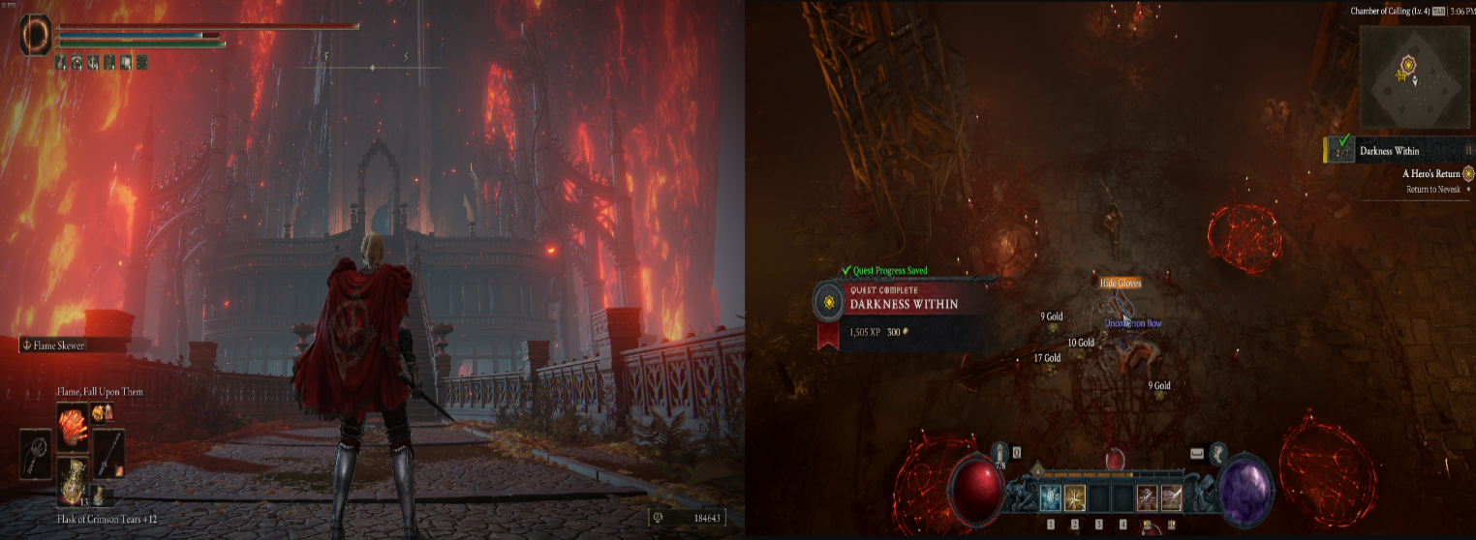

Image 01: *ELDEN RING* UI vs *Diablo IV* UI

# Key Characteristics

## Minimalism

UI in all FromSoftware Soulslike games is extremely unobtrusive, even fading out completely when not in use. This encourages the player to be more aware of the game world and emphasizes player immersion over reliance on UI. This, in turn, fits with the high difficulty level the games are known for, making even the UI’s design a part of the games’ philosophy.



Video 01: UI fading in/out

## Atmospheric design & high visual fidelity

UI is designed to match the tone and theme of the game’s world, and for FromSoftware games, that’s usually gothic, decayed, or medieval. Icons and menus are especially made to have a dark fantasy art style, that supports the tone of hopelessness and mystery of the world. Therefore, UI also serves worldbuilding purposes, and especially in older games, puts the convenience of the player second.

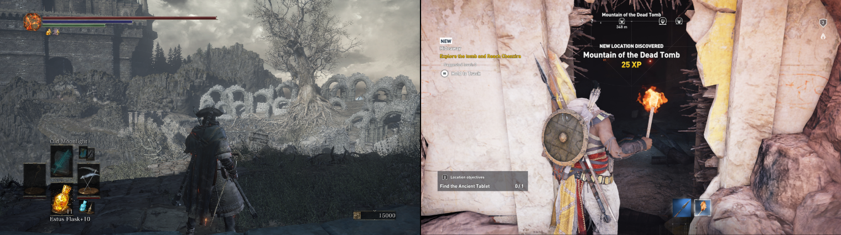

Image 02: *Dark Souls 3* vs *Assassin’s Creed: Origins*

## Purposeful Opaqueness

Information is intentionally cryptic and hidden, requiring players to engage deeply with systems and lore. Item descriptions, stats and status effects often have layered meanings or hidden benefits, and for FromSoftware developers, they’re one of the main places to go to for the lore.

For example, in the case of the item displayed below, the player would have to read the description of the item to know that it does extra damage to the hollow type of enemy, and that this greatsword, unlike others, can execute special techniques. There is no flashing information indicator for the item that says, “*Plus 15% damage to hollows*”.

Players are meant to learn by doing, through trial, many, many failures, and observation.

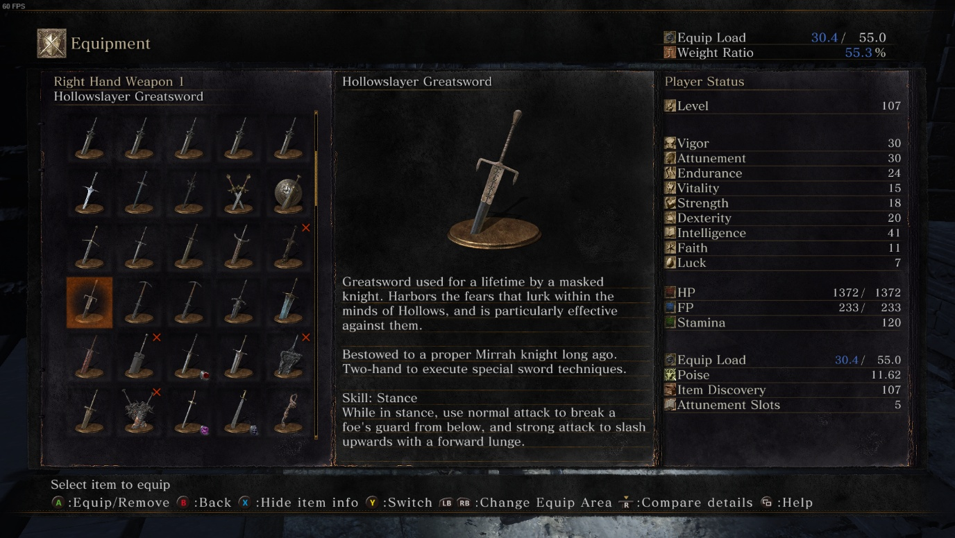

Image 03: Equipment Inventory Dark Souls 3 – Hollowslayer Greatsword Item Description

# Core UI Elements

* **Health / Stamina / Mana bars:** Always positioned on the top-left of the screen, flat and iconic with high visibility
* **Enemy Health bar:** For regular enemies, shown atop their heads, while for bosses it is shown at the bottom of the screen
* **Weapon / Item Slots:** Bottom Left Corner, D-pad Layout. Represents healing items, magic and consumables.
* **Currency counter:** Bottom Right Corner, name (i.e. souls, runes) depends on the game.
* **Status Effects:** Minimal icons for debuffs / buffs, below the health/stamina/mana bars. Never explained or detailed fully, unless the player explores their description in the inventory.
* **Pop-up Messages:** The classic “You Died” message, “Prey Slaughtered”, “Bonfire Lit” etc. Simple, but deeply thematic.

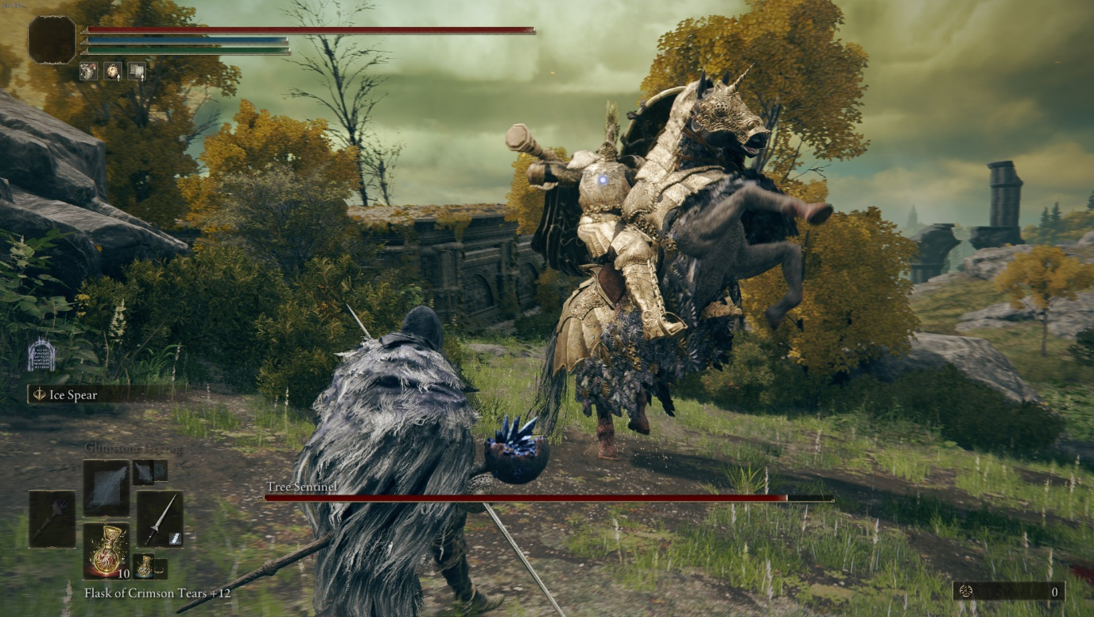

Image

# Conclusion

The UI in Soulslike games is not just a tool to display information to the player – it creates immersion, tension and is a very powerful storytelling tool. By focusing on minimalism, these interfaces achieve more with less, letting the game’s atmosphere shine through. This type of design has become a staple in the industry, and as I develop my own game, I intend to carry forward this design philosophy. As I am still a beginner UI designer, I am reluctant to say I will be able to replicate this design fully. However, my end goal is to build an interface that doesn’t just provide the player with information but embodies the core of the game itself.